Mark Skidmore/Guilherme Martins

CS302 Data Structures
Fall 2008 - Dr. George Bebis

Programming Assignment 4
Due Date: 11/20/2008

I. Introduction

The primary purpose of this program is to perform and demonstrate coin recognition from gray-level images. Specifically, the program works in two parts: (1) read in a gray-level image containing a group of the same coins and comput mean size and standard deviation and (2) use this information to read in a gray-level image of a group of different coins, identify them and sum their value. Other functions include:

- Create a sorted list of the different coins
- Create an unsorted list of the respective x,y coordinates of the pixels of a coin
- Compute the centroid of each coin
- Display coins by value
- Compute the value of a coin

Part 1 is implemented in the train.cpp file and Part 2 is implemented in the recognize.cpp file. Each of these implementations is detailed in the Program Implementation and Results section. Train.cpp must be run before recognize.cpp in order to compute coin statistics. Both drivers provide a menu interface for the user as described in the next section.

II. Program Usage

The program is simple to use. In a command window, navigate to the 4TAssignmen/Train folder containing the program files. Then from the command line, simply run the executable by typing ./train.bin and follow the on-screen prompts and menu as shown below in Illustration 1.

The user can choose to process any of the coins listed below.

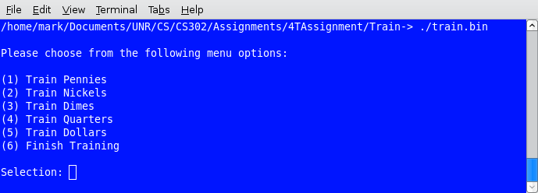Illustration 1: Train Menu List
Menu items 1 through five are identical and only item 1 will be demonstrated. By choosing 1, the use will be prompted for the following inputs:

The user will be asked to enter a file to process as show in Illustration 2. In this example, pennies are being processed.

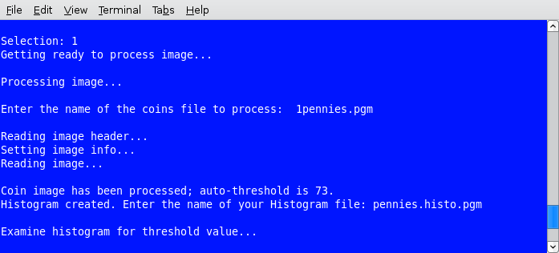Illustration 2: Program Run

Once the user makes a selection, he/she will be prompted to enter a file name as shown in Illustration 3. Once the file name is entered, the program will begin processing the image. Although the program provides an automatic thresholded value, the user can either re-enter the same value or examine the histogram and enter a new value.

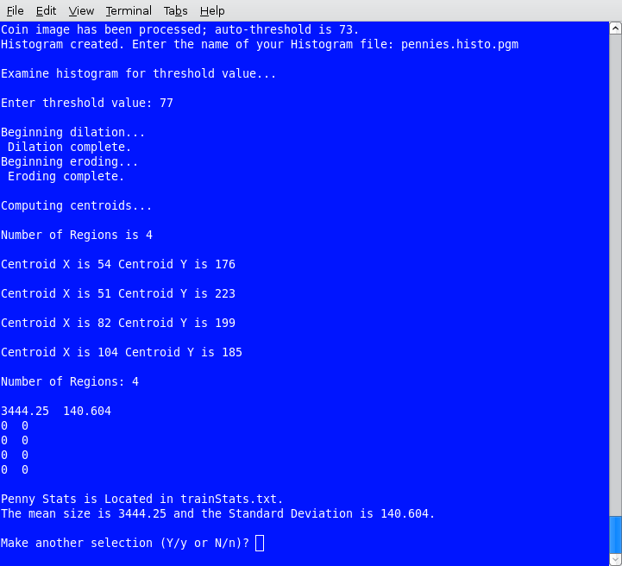Illustration 3: Program Run
After the threshold value is entered, the program continues to process the image. Dilation, erosion and centroid computation is performed. An on-screen list of each mean and standard deviation is listed in tabular format as well as written to a text file. The same process can be performed for remaining coins.

Once training is completed, the recognition process can be performed. In the same directory, type recognize.bin and follow the on-screen menu and prompts as shown in Illustration 4.

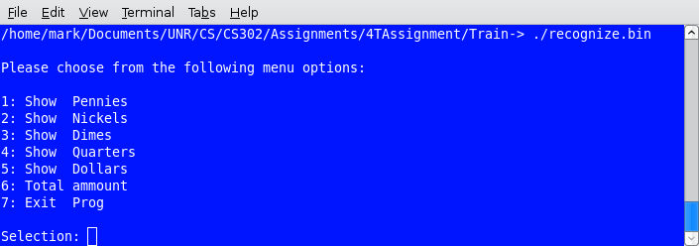Illustration 4: Recognize Menu
The user can choose any of the above menu items. In this example, Pennies will be demonstrated. By choosing 1, the user will be prompted to enter an image file to process.

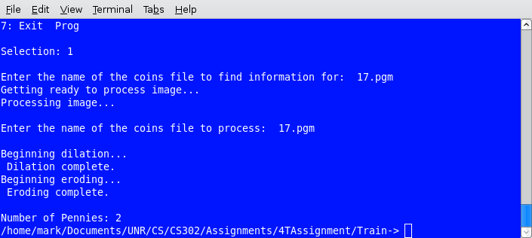Illustration 5: Recognize Coins

Illustration 5 shows the user entering an image file with 17 cents (one dime, two pennies and a nickel. See Illustration 6). being processed. At each prompt, enter the same file name. The program will process the image and extract those coins corresponding to the menu choice. Once the processing is complete, the program will write a file to the program directory containing only those coins corresponding to the user's choice. Illustration 7 below shows that the two pennies in 17.pgm were extracted and written to a file.

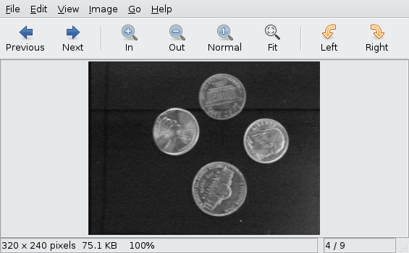Illustration 6: 17.pgm

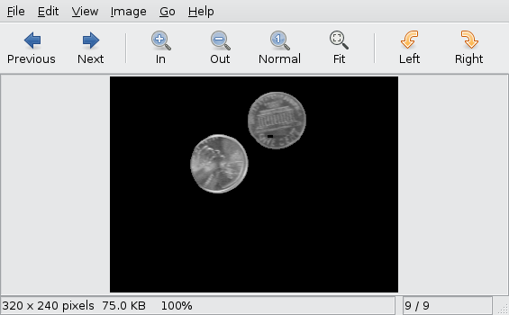Illustration 7: 17.pgm Showing only Pennies

Choosing menu item 6 in recognize will count and produce the total value of coins in an image as show in Illustration 8. For example, 130.pgm should show the value of the one nickel, one quarter and one dollar.

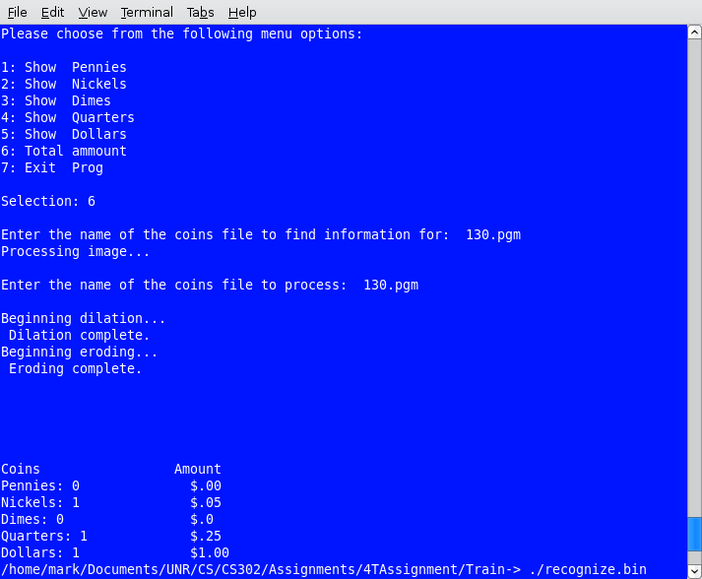Illustration 1: 130.pgm

III. Program Implementation and Results

Train.cpp and recognize.cpp are the two main drivers for the program. Each driver and respective functions are described below.

A. train.cpp Client Functions.

int displayMenu()

Displays the menu system to the user. Called from within main and remains active until the user chooses to exit. Returns an integer value to be used in the executeCase function.

void executeCases(int choice, float[][2]);

Accept the user's choice (1 through 6) returned from displayMenu(). Called from within main and remains active until the user chooses to exit. Passes a main-declared 2D array to store coin mean and standard deviation statistics to those functions which compute statistics for penny, nickel, dime, quarter, and dollar coins.

char validateResponse();

Validates the user's input to the displayMenu() function. Returns yes or no char to indicate user's choice to continue program usage (Y) or termination (N).

void trainPennies(ImageType&, float[][2]);

The first of five functions to compute coin statistics, specifically those for a penny. Passes executeCases()-instantiated image type object and 2D array object from main. Instantiates a sorted Region (coin) List (by region size) and Region Type (coin node) object. RegionType contains the following public members:

- regionID – unique coin identifier
- regionSize – coin size in pixels
- Xcentroid – x coordinate of the center of the coin
- Ycentroid – y coordiante of the center of the coin
- PixelList<PixelType> - list of the coin's pixels in x,y coordinates

The function successively calls processImage(), coinStats() and saveStats() function to perform coin training.

void trainNickels(ImageType&, float[][2]);

The second of five functions to compute coin statistics, specifically those for a penny. Passes executeCases()-instantiated image type object and 2D array object from main. Instantiates a sorted Region (coin) List (by region size) and Region Type (coin node) object. RegionType contains the following public members:

- regionID – unique coin identifier
- regionSize – coin size in pixels
- Xcentroid – x coordinate of the center of the coin
- Ycentroid – y coordiante of the center of the coin
- PixelList<PixelType> - list of the coin's pixels in x,y coordinates

The function successively calls processImage(), coinStats() and saveStats() function to perform coin training.

The function successively calls processImage(), coinStats() and saveStats() function to perform coin training.

void trainDimes(ImageType&, float[][2]);

The third of five functions to compute coin statistics, specifically those for a penny. Passes executeCases()-instantiated image type object and 2D array object from main. Instantiates a sorted Region (coin) List (by region size) and Region Type (coin node) object. RegionType contains the following public members:

- regionID – unique coin identifier
- regionSize – coin size in pixels
- Xcentroid – x coordinate of the center of the coin
- Ycentroid – y coordiante of the center of the coin
- PixelList<PixelType> - list of the coin's pixels in x,y coordinates

The function successively calls processImage(), coinStats() and saveStats() function to perform coin training.
void trainQuarters(ImageType&, float[][2]);

The fourth of five functions to compute coin statistics, specifically those for a penny. Passes executeCases()-instantiated image type object and 2D array object from main. Instantiates a sorted Region (coin) List (by region size) and Region Type (coin node) object. RegionType contains the following public members:

- regionID – unique coin identifier
- regionSize – coin size in pixels
- Xcentroid – x coordinate of the center of the coin
- Ycentroid – y coordiante of the center of the coin
- PixelList<PixelType> - list of the coin's pixels in x,y coordinates

The function successively calls processImage(), coinStats() and saveStats() function to perform coin training.
void trainDollars(ImageType&, float[][2]);

The fifth of five functions to compute coin statistics, specifically those for a penny. Passes executeCases()-instantiated image type object and 2D array object from main. Instantiates a sorted Region (coin) List (by region size) and Region Type (coin node) object. RegionType contains the following public members:

- regionID – unique coin identifier
- regionSize – coin size in pixels
- Xcentroid – x coordinate of the center of the coin
- Ycentroid – y coordiante of the center of the coin
- PixelList<PixelType> - list of the coin's pixels in x,y coordinates

The function successively calls processImage(), coinStats() and saveStats() function to perform coin training.

void processImage(ImageType& image, RegionList<RegionType>& regionList);

Receives image and regionList objects to continue and complete coin processing. Uses the readImageHeader(), and readImage() functions to initialize the image object as described in Assignment 1. Then calls image.displayHistogram(image, threshold) to produce a histogram for the user to manually choose a threshold value which is used by the subsequent call to image.threshold(threshold, image) function. image.dilate(image) and image.erode(image) are then called in order to prepare image for final call to findComponentBFS(image, outputImage, regionList) as previously described in Assignment 3.

findComponentBFS(image, outputImage, regionList);

Finds connected components in binary image using a queue to process image and produce corresponding outputImage with counted and labeled coins. The algorithm uses eight pixels in the form of a 3 by 3 square surrounding a center pixel, (I, j), of image. Each of these neighbors is stored in the queue so that they can be labeled in future iterations.

void findComponentBFS(ImageType&, ImageType&, RegionList<RegionType>&);

Same function as described in Assignment 3 but modified to accept RegionList of RegionTYpe. Finds connected components in binary image using a queue to process image and produce corresponding outputImage with counted and labeled coins. The algorithm uses eight pixels in the form of a 3 by 3 square surrounding a center pixel, (I, j), of image. Each of these neighbors is stored in the queue so that they can be labeled in future iterations. Each I,j pair is stored in the public members, I,j, of a pixelType object which is inserted into a pixel list for each region (coin). Once all pixelTypes have been computed, their length can be determined (pixelList.LengthIs()) and inserted into respective regionType along with each list. Only those regions for which the pixel count is greater than 30 are inserted into the list of regions; otherwise, the deleteSmallHoles() functions is called to remove non-coin regions from the image. Lastly, computeRegionCentroid(regionList) is called to compute the centroid components of each coin.

void deleteSmallHoles(RegionList<RegionType>& regionList, int size);

Deletes regions less than thirty pixels in size. Called from findComponentBFS().

void computeRegionCentroid(RegionList<RegionType>& regionList);

Computes and sets the x,y coordinates of each centroid of a region. Called from within findComponentBFS().

void coinStats(RegionList<RegionType>& regionList, float& mean, float& StdDev);

Called from within each train<Coin>() function to compute the mean size and standard deviation of a coin.

void saveStats(float mean, float StdDev, float coinSize[][2], int size);

Called from within each train<Coin>() function to write coin statistics to file trainStats.txt for use in recognize.cpp.

B. recognize.cpp Client Functions.

void makestatfiles();

Called from within main to read in trainStats.txt file from train.cpp. Writes each coin's mean to a respective text file for future use.

void displayMenu();

Displays the menu system to the user. Called from within main. User's choice is then passed to executeCase() function to be used in switch to perform coin recognition.

void executeCases(int choice);

Performs user's choice selection to perform coin recognition of a penny, nickel, dime, quarter or dollar. Also computes total value of different coins in an image.

void recogpennies(ImageType&, char[20]);

Case 1 of executeCases(). Instantiates a regionList object which is passed to called processIMage() function for coin processing.

void recognickels(ImageType&, char[20]);

Case 2 of executeCases(). Instantiates a regionList object which is passed to called processIMage() function for coin processing.

void recogdimes(ImageType&, char[20]);

Case 3 of executeCases(). Instantiates a regionList object which is passed to called processIMage() function for coin processing.

void recogquarters(ImageType&, char[20]);

Case 4 of executeCases(). Instantiates a regionList object which is passed to called processIMage() function for coin processing.

void recogdollars(ImageType&, char[20]);

Case 5 of executeCases(). Instantiates a regionList object which is passed to called processIMage() function for coin processing.

void total(RegionList<RegionType>&, char[20]);

Case 6 of executeCases(). Performs total value determination of coins in an image. Calls processImage() to clean image and manipulate it.

void processImage(ImageType&, RegionList<RegionType>&);

Performs same image processing as that in train.cpp. See train.cpp for function description.

void findComponentBFS(ImageType&, ImageType&, RegionList<RegionType>&);

Performs same image processing as that in train.cpp. See train.cpp for function description.

void FinishedCoins(RegionList<RegionType>&,int, ImageType&, char[20]);

int recogcoins(RegionList<RegionType>&,char[],ImageType&, char[20]);

void deleteSmallHoles(RegionList<RegionType>&, int);

Performs same image processing as that in train.cpp. See train.cpp for function description.

C. The Image Class Functions.

ImageType();

The default constructor. Sets row, column, gray-level values to zero; sets pixelValue member to NULL

ImageType(int, int, int);

The parameter constructor. Accepts temporary row, column and gray-level parameters then returns current respective values. Sets all pixel values to zero.

ImageType(const ImageType &object);

Implemented and tested but not used.

void getImageInfo(int& rows, int& cols, Int& levels);

Returns by reference the number of rows and columns of the image, and the max pixel value.

void getPixelVal(int i, int j, int& val );

Returns the pixel value by reference at (i, j) location. Bounds checking is done in main (but should have been done in this function to provide more robustness to client calls).

void setPixelVal(int i, int j, int val);

Sets the pixel value at location (i, j) to val. Bounds checking is done in main (but should have been done in this function to provide more robustness to client calls).

int computeAvgGrayLevel(const ImageType &object);

Returns the average gray-level of object. For each row then for each column, sums all pixel values in the 2D array then divides by the number of cells (row x columns) to compute an average.

ImageType enlargeImage(int e, ImageType &object);

Enlarges object. Instantiates a temporary Image object to store object parameter by row then by column processing. A second temporary object is instantiated then set equal to object using a row loop from 0 to rows times e and a column loop from 0 to columns times e while the object's rows and columns are set to i/e and j/e, respectively. Returns an image type object.

ImageType shrinkImage(int s, ImageType &object);

Reduces object. Instantiates a temp object and populates with object using two nested for loops then zeroizes the original object. Next, uses row and column nested for loops and increments by s in each loop, cycles through each cell of the temp object and assigns to corresponding object rows and columns divided by s. Then, uses previous loop structure but with column upper bound divided by s, assigns temp cells to corresponding object cells, again with columns divided by s. Lastly, with two nested for loops with upper bounds divided by s but one less than number of rows and columns, respectively, object is assigned to previously instantiated second temp object. Returns second temp object.

void getSubImage(int ULr,int ULc, int LRr,int LRc, ImageType& object)

Returns a sub-image of object. Instantiates a temp image object to which object is assigned then object is zeroized. Two nested for loops, from Upper-Left row (ULr) to Lower-Right row (LRr) and from Upper-Left column (ULc) to Lower-Right column (LRc) then re-populate object with temp object values. Returns object by reference.

void negateImage(ImageType &object)

Negates object. For each row and column of object, object is assigned the absolute value of 255 minus each pixel value of object. Returns object by reference.

void reflectImage(ImageType &object)

Reflects object about the vertical or horizontal axis. Object is assigned to instantiated temp object then zeroized. User is then asked to choose between horizontal and vertical reflection. A switch statement then performs the corresponding choice. Both reflections use two nested for loops – the horizontal's column loop descends from column less one while the vertical's row loop descends from row less one. Reflected image is returned by reference.

ImageType translateImage(int t, ImageType &object)

Shifts an image in the -X and +Y directions by amount t. Assigns object to instantiated temp object. If each row and column index plus the translation amount sum to less than the object's row and column values then the translated values are set in temp and temp is returned by reference.

void rotateImage(int N, int M, float theta, ImageType &object)

Rotates object by a user-specified angle. Object is assigned to instantiated temp object then zeroized. New row and column coordinates are then computed with the following formulas:

R = Xc + int(((i - Xc)*(cos(theta)) - (j - Yc)*(sin(theta))) + 0.5);

C = Yc + int(((i - Xc)*(sin(theta)) + (j - Yc)*(cos(theta))) + 0.5);

where Xc and Yc are N/2 (row) and M/2 (column), respectively; theta is the angle in radians, i and j are row and column incrementers, respectively. Casting is performed to convert calculations to an integer while the addition of 0.5 rounds the integers to the nearest integer. Bounds checking is performed to set pixel values to zero for those R and C coordinates that fall outside of object's row and column dimensions. Returns rotated object by reference.

bool inBounds(int R, int C)

Performs row and column bounds checking for rotateImage();.

ImageType displayHistogram(ImageType& object, int& valley)

Called from countLabelRedions() in processImageMain.cpp; counts each pixel value in each cell of object and stores in a 1-D array from 0 to 255. Performs smoothing to facilitate thresholding in threshold() function. Finds threshold value of object and stores in valley. Returns histogram object.

void threshold(int threshold, ImageType &object)

Called from countLabelRegions() in processImageMain.cpp; uses threshold to produce a binary image of object.

void dilate(ImageType& object)

Called from countLabelRegions() in processImageMain.cpp; receives binary (black and white) object and attempts to fill the small holes with white pixels which thresholding missed. Image is expanded during dilation and must be eroded using erode() function.

void erode(ImageType& object)

Called from countLabelRegions() in processImageMain.cpp; receives dilate object from dilate() then returns each coin in object to its original size.

void operator= (const ImageType &object)

Used when overloaded + and – operators are invoked.

ImageType operator + (ImageType &object)

Used to add two objects.

ImageType operator - (ImageType &object)

Used to subtract one object from another.

~ImageType()

Releases memory used by pixelValue row pointers then pixelValue double pointer upon program termination.Calls makeEmpty() function to deallocate all elements.

D. The RegionList (Sorted) Class (RegionList.h/cpp).

This is a sorted list implementation which contains standard sorted list functions and is covered in class slides and the text.

E. The RegionType Class (RegionType.h/cpp).

Provides following public members for use with the RegionList class:
- regionID – unique coin identifier
- regionSize – coin size in pixels
- Xcentroid – x coordinate of the center of the coin
- Ycentroid – y coordiante of the center of the coin
- PixelList<PixelType> - list of the coin's pixels in x,y coordinates

Also contains the following public functions to manipulate the aforementioned members:
- RegionType(); - Default Class constructor

- void insert(int, int, float, float, PixelList<PixelType>);
- insert function to insert a RegionType object into RegionList. Implemented from train.cpp and recoginize.cpp
- RegionType& operator= (RegionType&); - Overload equals
operator. Implemented from train.cpp and recoginize.cpp
- ~RegionType(); - Class destructor

- bool operator < (RegionType);
- Overloaded less than operator. Implemented from recognize.cpp
- bool operator ==(RegionType); - Overloaded assignment operator. Implemented from recognize.cpp

- bool operator !=(RegionType); - Overloaded not equals operator. Implemented from recognize.cpp

F. The Pixel List (Unsorted) Class (PIxelList.h/cpp).

This is an unsorted list implementation which contains standard sorted list functions and is covered in class slides and the text.

G. The PixelType Class (PIxelType.h/cpp).

Provides following public members for use with the PixelList and RegionList classes:

- I – the x or row coordinate of a pixel
- j – the y or column coordinate of a pixel

Also contains the following public functions to manipulate the aforementioned members:

- PixelType(); - default constructor
.
- PixelType(PixelType&); - copy constructor
.
- void insert(int y, int x); - insert function to insert row and column pixel values. Implemented from train.cpp and recognize.cpp.
- PixelType& operator= (PixelType&);
- overloaded operator equals function.Implemented from train.cpp and recognize.cpp.
- ~PixelType(); - Class destructor.

H. The NodeType Class (NodeType.h) Functions.

Provides following public members for use with the PixelLIst/PixelType and RegionList/RegionType classes:

- ItemType info;
- acts as the data type for either a RegionType or PixelType object in RegionList or PixelList, respectively.
- NodeType<ItemType> *next; - pointer to the next RegionType of PixelType in RegionList or PixelList, respectively.

I. Supplied Functions (Supplied by Dr. Bebis and restated here for document completion).

int readImageHeader(char[], int&, int&, int&, bool&);

Reads the header information of an image file. Stores the filename in char[],tests for a valid file. If file is valid, reads the header and test for P5 (PGM) or P6 (PPM) image types If P5, retrieves row, column and max pixel value information.

int readImage(char[], ImageType&);

Reads an image from a file. The pixel values are stored in an array and the image width, height, and number of gray-levels are recorded in the appropriate fields. A NOT-PGM exception should be raised if the image file to be read is not in PGM format (image is an object of type ImageType).

writeImage(fileName, image):

Writes an image to a file using a user supplied filename in the appropriate format (image is an object of type ImageType).

J. Results

The program executes as expected with exception noted in Section IV. The Training functions successfully read in an image of a group of pennies, nickels, dime quarters and a dollar and compute respective mean and standard deviations which are written to trainStats.txt. The recognize class subsequently reads in trainStats.txt and performs coin recognition. I.e., the class will read in an image of a group of coins, identify each one, then either display the desired coins of the same value or count and display the total value of all coins in the image.

Note; train.cpp must be run before recognize.cpp.

Note: Dilation must run before Erosion. Calling Erosion before Dilation will cause a segmentation fault.

IV. Bugs and Errors

Images that are incorrectly thresholded will cause a segmentation fault. Users must examine the histogram and provide a reasonably accurate threshold value during the train process.

VII. Partner Contributions.

Both partners contributed 50% each to the assignment.

